ELEC 2210 LABORATORY REPORT COVER PAGE

Complete and attach this page to the front of your lab report.

Meeting # 002 EXPERIMENT 3: Medium Scale Integrated (MSI) Circuits *Title of Lab Experiment*

Student Name: Howard Jacob, A

*Name (Last, First, MI)*

Student Email: JAH0147

*AU 7-character username*

GTA: Jonathan

*Name of your GTA*

The section you are enrolled in: (Circle One): 1 2 3 4 5 6 7 8

Date experiment performed (dd / mm / yy): 15/9/20

Date report submitted: (dd / mm / yy): 22/9/20

If you performed this experiment at a time other than your regularly scheduled section meeting:

Section # of the section you sat in on (Circle One): 1 2 3 4 5 6 7 8 Makeup

Name of the GTA who supervised your work: None

I hereby certify that the contents of this report are true and complete to the best of my ability. The lab work was performed by me exclusively, and this report was written by me exclusively.

Jacob Howard 16/9/20

Student signature Date signed

ELEC-2210

Digital Electronics

FROM: Jacob Howard

TO: Jonathan

DATE: 9/15/20

LAB SECTION: 002 (Tuesday, 1:00pm-2:50 pm)

EXPERIMENT 5:

Switch Debounce Circuits

# **Introduction**

# For this lab, we reviewed the basic concept of latches in our prelab and lab exercises. For our lab, we were introduced to a physical button as a switch. We were also introduced to the oscilloscope software that would help us measure different things. We used the ElVIS Board to wire our circuits.

# **Step 1**

This lab concisted of four parts. For the first part we only used the provided pushbutton. We wired the push button by following the directions in the Lab Manual. The goal of this was to make sure that the SPDT push button was working properly. Once wired correctly, we had a lit LED 7 and a turned off LED 6. Every time the button was pressed the LED6 would turn on and LED 7 would go off. We connected the LEDs to the Digital Reader just to double check that the button was working properly. With everything working, we assured that the pushbutton was functional.

# **Step 2**

For step 2 of the lab, we connected the RS latch shown in *Figure 1* to LEDs 4 and 5 and to DIO 12 and 13. These will be the outputs of the Latch. We mostly followed our Prelab design for this part. We did not connect the button to the end of the latch, instead we used the Digital Writer to input the values with diodes 0 and 1. We made sure that the latch was working properly by comparing out results with the ones shown in Table 1.

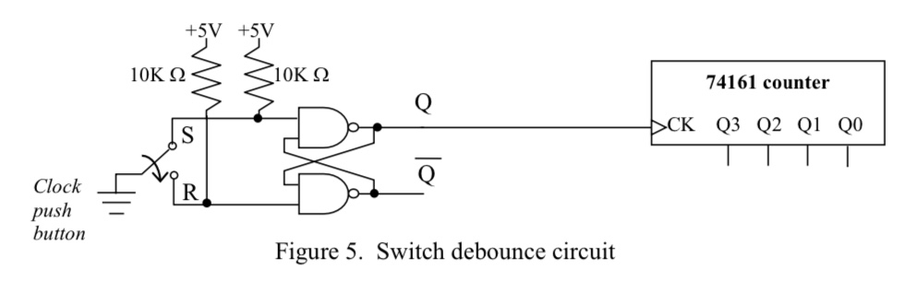

*Figure 1*

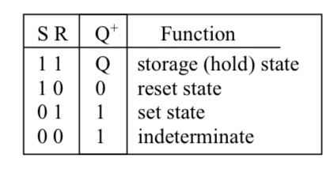

*Table 1*

# **Step 3**

# For Part 3 we disconnected the Digital Writer from the latch and connected it to the button. We then set up the Oscilloscope with the required settings and took measurements of what happened when wepressed the button.

# **Step 4**

# For Part 4 we completed the connections done in our Prelab by connecting the 74161 chip as a counter. Using the output of the latch as the clock input we observed the results in the oscilloscope. We then repeated the same process, but with a non denounced pushbutton output. We could see the bounce on the oscilloscope and how the bounce effected the output of the LEDs. The bounce made the counter skip.

# **Conclusion**

This lab was not too bad. It was interesting to see how bounce can effect an output and how to resolve this issue with a debouncer. This lab was very helpful to see how digital logic is used to solve real world problems.